Feeding JSON data to Kafka Topic Using Rest Proxy
Contents:
- Introduction
- Prerequisites
- Procedure to feed json data to Kafka Topic

Kafka REST Proxy

Introduction:
This POC describes the procedure of feeding JSON format data to a Kafka Topic using Kafka REST Proxy, that which provides a RESTful interface to a Kafka cluster.

Prerequisites:
Before you start this procedure, ensure that :
- Have administrative access to running Kafka VM and that VM must have connectivity as described in the loading Prerequisites.
- Identify and note the ZooKeeper hostname and port.
- Identify and note the hostname and port of the Kafka broker(s).
- Identify and note the hostname and port of the Kafka Rest Proxy.
Note: This procedure assumes that you have installed the Apache Kafka distribution. If you are using a different Kafka distribution, you may need to adjust certain commands in the procedure.

Note: Here, In this Use case we have configured hostnames and ports with the following
rest-proxy localhost: 8082
zookeeper localhost: 2182
bootstrap-server localhost: 9095

Procedure to feed json data to Kafka Topic:

Step 1: Login to a host in your Kafka VM
$ cd kafka_2.12-2.4.0 /*if this dir does not exit, Use ls command to view the folder and copy/paste the existing folder*/
To list out, all the topics which are present inside that kafka topics
$ bin/kafka-topics.sh --list --zookeeper localhost:2182 /*To check/verify and to display all the topics*/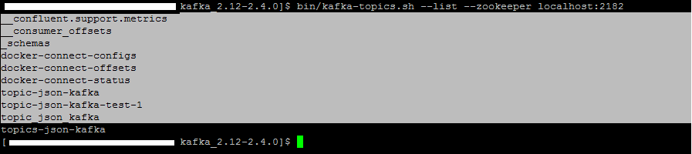
Step 2: Create a Kafka topic
Here, create a topic named " topic-test-1" with a single partition and only one replica:
For example:
$ bin/kafka-topics.sh --create --zookeeper localhost:2182 --replication-factor 1 --partitions 1 --topic topic-test-1
$ bin/kafka-topics.sh --list --zookeeper localhost:2182 /*To check or to list out the created topic*/
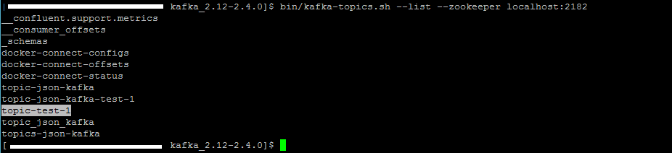

Step 3: Create a json file
Create a file named sample- json-data.json in the editor of your choice.
For example:
$ vi sample-json-data.json
then, paste some json format text and add it to a file, and then save the file and exit
For example:
{
"first_name": "Tom",
"last_name": "Cruze",
"email": "Cruze@gmail.com",
"gender": "Male",
"ip_address": "1.2.3.4"
}
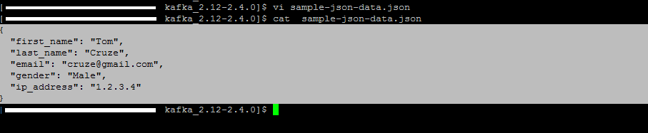

Step 4: To stream the contents of the json file to a Kafka console producer
$ bin/kafka-console-producer.sh --broker-list localhost:9095 --topic topic-test-1 < sample-json-data.json
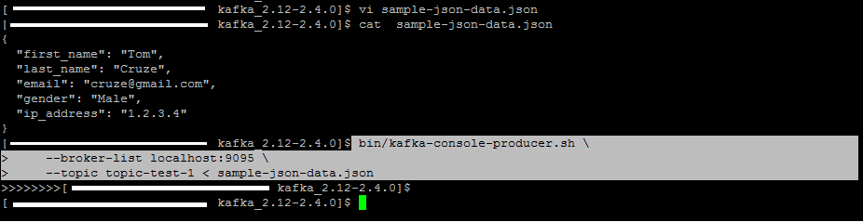
Step 5: To verify that the Kafka console producer published the messages to the topic by running a Kafka console consumer
$ bin/kafka-console-consumer.sh --bootstrap-server localhost:9095 --topic topic-test-1 --from-beginning
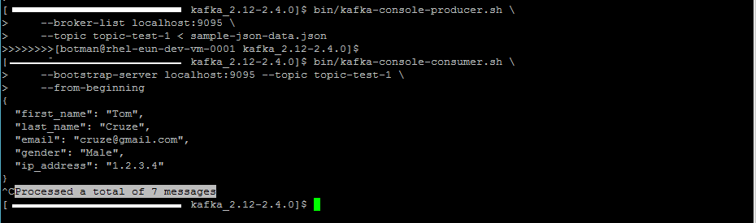

Step 6: To stream the contents of the other json file to a Kafka console producer
For example:
$ vi sample.json
then, paste some json format text and add it to a file, and then save the file and exit
{ "cust_id": 1313131, "month": 12, "expenses": 1313.13 }
{ "cust_id": 3535353, "month": 11, "expenses": 761.35 }
{ "cust_id": 7979797, "month": 10, "expenses": 4489.00 }
{ "cust_id": 7979797, "month": 11, "expenses": 18.72 }
{ "cust_id": 3535353, "month": 10, "expenses": 6001.94 }
{ "cust_id": 7979797, "month": 12, "expenses": 173.18 }
{ "cust_id": 1313131, "month": 10, "expenses": 492.83 }
{ "cust_id": 3535353, "month": 12, "expenses": 81.12 }
{ "cust_id": 1313131, "month": 11, "expenses": 368.27 }

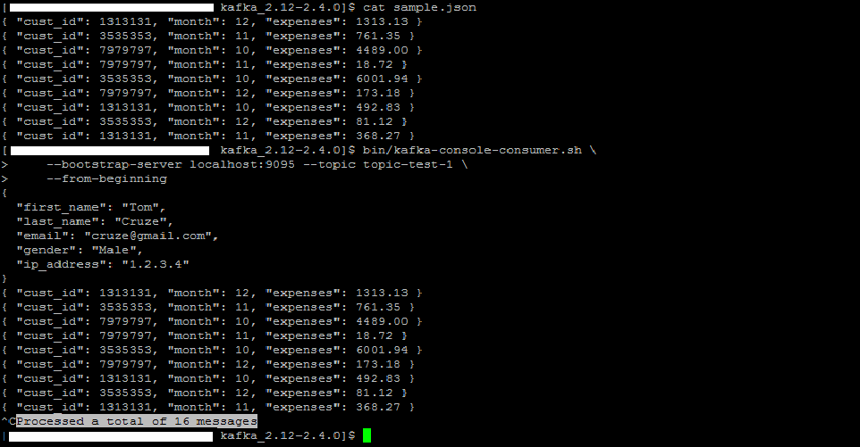

Kafka REST Proxy:
The Kafka REST Proxy provides a RESTful interface to a Kafka cluster. It makes it easy to produce and consume messages, view the state of the cluster and to perform administrative actions without using the native Kafka protocol or clients.

To get the list of topics using curl
$ curl "http://localhost:8082/topics"

To get the info of one topic
$ curl http://localhost:8082/topics/<menction topic name>
For example:
$ curl "http://localhost:8082/topics/topic-test-1"

Step 1: To Produce a message using JSON with a value to a topic
For example, to produce a message using JSON with a value '{ "month": 12}' to the topic topic-test-1
$ curl -X POST -H "Content-Type: application/vnd.kafka.json.v2+json" \
-H "Accept: application/vnd.kafka.v2+json" \
--data '{"records":[{"value":{"month": 12}}]}' "http://localhost:8082/topics/topic-test-1"
/*Expected output from preceding command*/
{
"offsets":[{"partition":0,"offset":16,"error_code":null,"error":null}],"key_schema_id":null,"value_schema_id":null
}
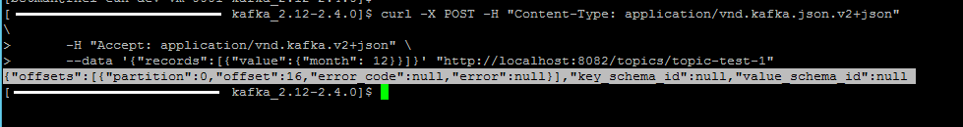
To verify that the Kafka console producer published the messages to the topic by running a Kafka console consumer
$ bin/kafka-console-consumer.sh --bootstrap-server localhost:9095 --topic topic-test-1 --from-beginning
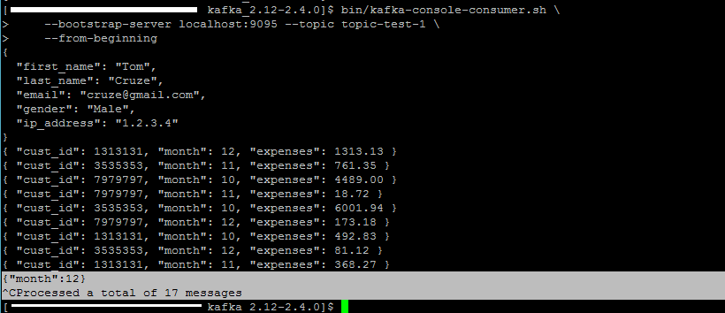

Step 2: Create a consumer for JSON data, starting at the beginning of the topic's
$ curl -X POST -H "Content-Type: application/vnd.kafka.v2+json" \
--data '{"name": "my_consumer_instance", "format": "json", "auto.offset.reset": "earliest"}' \ http://localhost:8082/consumers/my_json_consumer

/* Expected output from preceding command*/
{
"instance_id":"my_consumer_instance",
"base_uri":"http://localhost:8082/consumers/my_json_consumer/instances/my_consumer_instance"
OR
"base_uri":"http://rest-proxy:8082/consumers/my_json_consumer/instances/my_consumer_instance"
}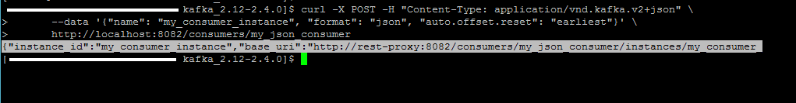

Step 3: Log and subscribe to a topic.
$ curl -X POST -H "Content-Type: application/vnd.kafka.v2+json" --data '{"topics":["topic-test-1"]}' \
http://localhost:8082/consumers/my_json_consumer/instances/my_consumer_instance/subscription
/* Expected output from preceding command*/
# No content in response
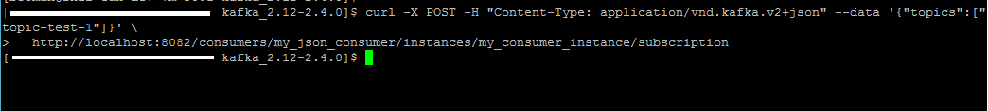

Step 4: To consume some data using the base URL in the first response.
$ curl -X GET -H "Accept: application/vnd.kafka.json.v2+json" \
http://localhost:8082/consumers/my_json_consumer/instances/my_consumer_instance/records
/* Expected output from preceding command*/
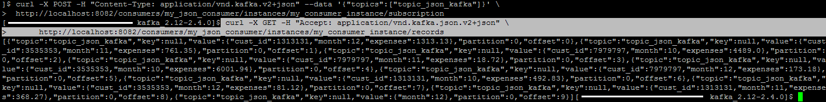

Optional Steps:
Step 1: Finally, to close the consumer with a DELETE to make it leave the group and clean up it's resources.
$ curl -X DELETE -H "Content-Type: application/vnd.kafka.v2+json" \
http://localhost:8082/consumers/my_json_consumer/instances/my_consumer_instance
/* Expected output from preceding command*/
# No content in response

Step 2: verify the consumer instance using the following command
$ curl -X GET -H "Accept: application/vnd.kafka.json.v2+json" \
http://localhost:8082/consumers/my_json_consumer/instances/my_consumer_instance/records
/* Expected output from preceding command*/
{ “error_code”: 40403, “message”: “Consumer instance not found.” }
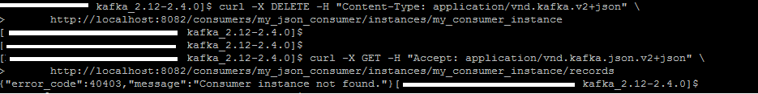

*** THE END ***

